**CURRENCy arbitrage trading**

**TEAM: SCATTERED BRAINS | 03/28/2020**

**CS 411: Database Systems Term: Spring 2020**

# Project Information

|  |  |
| --- | --- |
| Project Name | Currency Arbitrage Trading |
| Description | Currency Arbitrage Trading explores the opportunity resulting from a pricing discrepancy among different currencies in the foreign exchange market.  The daily exchange rates from European Central Bank (ECB) is analyzed for any possible arbitrage trading opportunities between base & target currency and provides intermediate trading currency details for arbitrage trading. |
| Team Name | **SCATTERED BRAINS** |
| Team Captain | Melany Rosales |
| Team Members | Melany Rosales  Nihar Samal  Prem Kumar Manoharan |
| Application Type | Android Mobile Application |
| Database Used | SQLite Version 3 (Prototyping)  Maria DB (Final Version) |
| Application Development Platforms Used | IDE:   * [Visual Studio 2019 Community Edition](https://visualstudio.microsoft.com/downloads/) (Free Version) * [Visual Studio Code 2019](https://code.visualstudio.com)   C#   * Xamarin * Xamarin Forms   Python   * Flask * MySQLdb * requests * etc.. |
| Database Platforms Used | Embedded DB   * [SQLite Studio](https://sqlitestudio.pl/index.rvt)   Hosted DB   * [MariaDB](https://mariadb.org) |
| Features | <Currency Arbitrage Trading -- Features & Special Functionalities To Be Added> |

# Data Models

## Physical Data Model

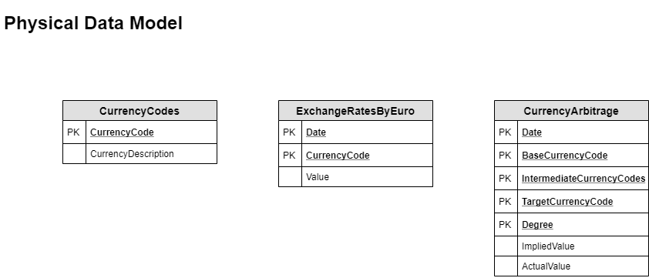

**need to update HEADERS**

## Entity Relationship Diagram

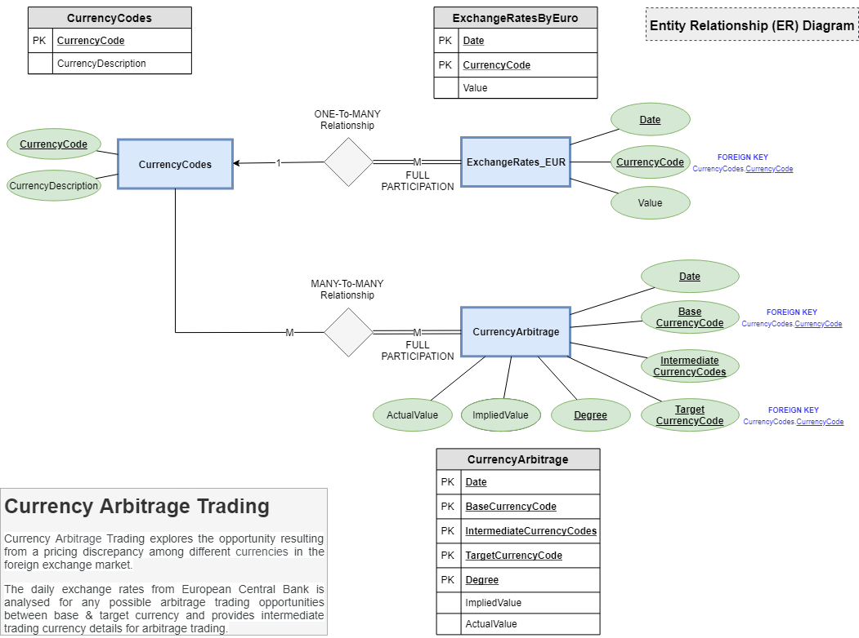

**need to update IMAGE**

# Tables & Schema Definitions

## Overview

Our project contains four major tables which are discussed below

1. Currency Codes
2. Currency Exchange Rates
3. Currency Exchange Rates Archive
4. Currency Arbitrage Log

## Table 1: Currency Codes

|  |  |
| --- | --- |
| Table Name | CurrencyCodes |
| Description | The CurrencyCodes table stores the Currency Code description along with their ISO 4217 Currency Code.  The CurrencyCode column value in this table is referred as Foreign Key by all the related tables in the application.  Currently only the exchange rates for the top 10 traded currencies are utilized in the arbitrage trading application to reduce the amount of permutations in the arbitrage calculations. |
| Columns | CurrencyCode (PRIMARY KEY)  CurrencyDescription |
| SQL Syntax | CREATE TABLE CurrencyCodes (  CurrencyCode VARCHAR (3) NOT NULL,  CurrencyDescription VARCHAR (50) NOT NULL,  PRIMARY KEY(CurrencyCode)  ); |
| Data Source | Currency codes are populated using information from the International Standards Organization. Values for the ISO 4217 Currency Codes Dataset are provided in an xml feed on the [ISO website](https://www.iso.org/iso-4217-currency-codes.html). Here’s the same information in .csv form from [XE currency exchange](https://www.xe.com/iso4217.php) platform. |

## Table 2: Currency Exchange Rates

|  |  |
| --- | --- |
| Table Name | CurrencyExchangeRates |
| Description | The CurrencyExchangeRates table stores the latest Exchange Rates between base and target currencies from the European Central Bank. |
| Columns | Date  BaseCurrencyCode  TargetCurrencyCode  ExchangeRate |
| SQL Syntax | CREATE TABLE CurrencyExchangeRates (  Date DATE NOT NULL,  BaseCurrencyCode VARCHAR(3) NOT NULL,  TargetCurrencyCode VARCHAR(3) NOT NULL,  ExchangeRate DECIMAL (65,30) NOT NULL,  FOREIGN KEY(TargetCurrencyCode) REFERENCES CurrencyCodes(CurrencyCode),  FOREIGN KEY(BaseCurrencyCode) REFERENCES CurrencyCodes(CurrencyCode),  PRIMARY KEY(Date,BaseCurrencyCode,TargetCurrencyCode)  ); |
| Data Source | The CurrencyExchangeRates table is populated using daily exchange rates data from the [European Central Bank (ECB) xml feed](https://www.ecb.europa.eu/stats/eurofxref/eurofxref-daily.xml) via the [Exchange Rates API](https://exchangeratesapi.io).  Every business day at 16:00 Central European Time the ECB updates their exchange rates. Our python scripts run every business day after their update to push the latest exchange rates between every base and target currency. |
| Web API Endpoints | Endpoints were created to connect with the latest exchange rates in this table.   * Get Latest Data * Get Latest Data by Code   Review the API End Points section for more details. |

## Table 3: Currency Exchange Rates Archive

|  |  |
| --- | --- |
| Table Name | CurrencyExchangeRatesArchive |
| Description | The CurrencyExchangeRatesArchive table stores historical Exchange Rates between base and target currencies from the European Central Bank. |
| Columns | Date  BaseCurrencyCode  TargetCurrencyCode  ExchangeRate |
| SQL Syntax | CREATE TABLE CurrencyExchangeRatesArchive (  Date DATE NOT NULL,  BaseCurrencyCode VARCHAR(3) NOT NULL,  TargetCurrencyCode VARCHAR(3) NOT NULL,  ExchangeRate DECIMAL (65,30) NOT NULL,  FOREIGN KEY(TargetCurrencyCode) REFERENCES CurrencyCodes(CurrencyCode),  FOREIGN KEY(BaseCurrencyCode) REFERENCES CurrencyCodes(CurrencyCode),  PRIMARY KEY(Date,BaseCurrencyCode,TargetCurrencyCode)  ); |
| Data Source | The CurrencyExchangeRatesArchive table is populated using the daily exchange rates data from the [European Central Bank (ECB) xml feed](https://www.ecb.europa.eu/stats/eurofxref/eurofxref-daily.xml) via the [Exchange Rates API](https://exchangeratesapi.io).  After data is inserted into the CurrencyExchangeRate table, the same information is also populated here for archival using a python script  USE a trigger for this? Advanced functionality? |
| Web API Endpoints | Endpoints were created to connect with the historical exchange rates in this table.   * Get Historic Data * Get Historic Data by Code * Get Historic Data by Date   Review the API End Points section for more details. |

## Table 4: CurrencyArbitrageLog

|  |  |
| --- | --- |
| Table Name | CurrencyArbitrageLog |
| Description | The CurrencyArbitrageLog table stores the set of Currency Arbitrage calculations performed on the given date and enables the User for any possible opportunities in arbitrage trading. |
| Columns | Date  BaseCurrencyCode  IntermediateCurrencyCodes  TargetCurrencyCode  Degree  ImpliedValue  ActualValue |
| SQL Syntax | CREATE TABLE CurrencyArbitrageLog (  Date DATE NOT NULL,  BaseCurrencyCode VARCHAR(3) NOT NULL,  IntermediateCurrencyCodes VARCHAR(512) NOT NULL,  TargetCurrencyCode VARCHAR(3) NOT NULL,  Degree INTEGER NOT NULL,  ImpliedValue DECIMAL(65,30) NOT NULL,  ActualValue DECIMAL(65,30) NOT NULL,  PRIMARY KEY(Date,BaseCurrencyCode,IntermediateCurrencyCodes,TargetCurrencyCode,Degree),  FOREIGN KEY(TargetCurrencyCode) REFERENCES CurrencyCodes(CurrencyCode),  FOREIGN KEY(BaseCurrencyCode) REFERENCES CurrencyCodes(CurrencyCode)  ); |
| Data Source | This table is populated using a python script that is run every business day after the ECB updates their exchange rates. |
| Web API Endpoints | Endpoints were created to connect with the arbitrage values of various degrees in this table.   * Get Currency Arbitrage Log   Review the API End Points section for more details. |

# API End Points

End points were created using Python 3 and flask framework to allow the Android application to communicate with the SQL server. This also allows users to query information from the database without the mobile application.

## Currency Codes

|  |  |
| --- | --- |
| Project Name | Description |
| URL | <http://cs411arbitrage.web.illinois.edu/test/GetCurrencyCodes> |
| Description | Pull the currency code and description for all available currencies. |
| Parameters | None |
| SQL Table | CurrencyCodes |
| SQL Command | SELECT CurrencyCode, CurrencyDescription FROM CurrencyCodes |
|  |  |
| Sample Output |  |

## Currency Exchange Rates

### Get Latest Data

|  |  |
| --- | --- |
| Project Name | Description |
| URL | <http://cs411arbitrage.web.illinois.edu/test/GetCurrencyExchangeRates> |
| Description | Pull the latest exchange rates between every base currency and target currency. |
| Parameters | None |
| SQL Table | CurrencyExchangeRates |
| SQL Command | SELECT Date, BaseCurrencyCode, TargetCurrencyCode, ExchangeRate FROM CurrencyExchangeRates |
|  |  |
| Sample Output |  |

### Get Select Latest Data by Code

|  |  |
| --- | --- |
| Project Name | Description |
| Base URL | <http://cs411arbitrage.web.illinois.edu/test/SelectCurrencyExchangeRates> |
| Description | Pull the latest exchange rates between a specific base currency and target currency. |
| Parameters | baseCode  targetCode |
| SQL Table | CurrencyExchangeRates |
| SQL Command | SELECT Date, BaseCurrencyCode, TargetCurrencyCode, ExchangeRate FROM CurrencyExchangeRates WHERE BaseCurrencyCode=\""+baseCode+"\" AND TargetCurrencyCode=\""+targetCode+"\" |
|  |  |
| Sample URL | <http://cs411arbitrage.web.illinois.edu/test/SelectCurrencyExchangeRates?baseCode=JPY&targetCode=USD> |
| Sample Output |  |

## Currency Exchange Rates Archive

### Get Historic Data

|  |  |
| --- | --- |
| Project Name | Description |
| URL | <http://cs411arbitrage.web.illinois.edu/test/GetHistoricCurrencyExchangeRates> |
| Description | Pull all historic exchange rates between every base currency and target currency. |
| Parameters | None |
| SQL Table | CurrencyExchangeRatesArchive |
| SQL Command | SELECT Date, BaseCurrencyCode, TargetCurrencyCode, ExchangeRate FROM CurrencyExchangeRatesArchive |
|  |  |
| Sample Output |  |

### Get Select Historic Data by Code

|  |  |
| --- | --- |
| Project Name | Description |
| Base URL | http://cs411arbitrage.web.illinois.edu/test/SelectHistoricCurrencyExchangeRates |
| Description | Pull historic exchange rates for a specific base currency and target currency. |
| Parameters | baseCode  targetCode |
| SQL Table | CurrencyExchangeRatesArchive |
| SQL Command | SELECT Date, BaseCurrencyCode, TargetCurrencyCode, ExchangeRate FROM CurrencyExchangeRatesArchive WHERE BaseCurrencyCode=\""+baseCode+"\" AND TargetCurrencyCode=\""+targetCode+"\" |
|  |  |
| Sample URL | <http://cs411arbitrage.web.illinois.edu/test/SelectHistoricCurrencyExchangeRates?baseCode=JPY&targetCode=USD> |
| Sample Output |  |

### Get Select Historic Data by Date

|  |  |
| --- | --- |
| Project Name | Description |
| Base URL | <http://cs411arbitrage.web.illinois.edu/test/SelectHistoricCurrencyExchangeRatesByDate> |
| Description | Pull historic exchange rates for a specific date |
| Parameters | Date |
| SQL Table | CurrencyExchangeRatesArchive |
| SQL Command | SELECT Date, BaseCurrencyCode, TargetCurrencyCode, ExchangeRate FROM CurrencyExchangeRatesArchive WHERE Date=\""+date+"\" |
|  |  |
| Sample URL | <http://cs411arbitrage.web.illinois.edu/test/SelectHistoricCurrencyExchangeRatesByDate?date=2020-04-03> |
| Sample Output |  |

## Currency Arbitrage Log

|  |  |
| --- | --- |
| Project Name | Description |
| Base URL | <http://cs411arbitrage.web.illinois.edu/test/SelectCurrencyArbitrageLog> |
| Description | Pull arbitrage data for a specific base currency, target currency, and degree |
| Parameters | baseCode  targetCode  degree |
| SQL Table | CurrencyExchangeRatesArchive |
| SQL Command | SELECT Date, BaseCurrencyCode, TargetCurrencyCode, IntermediateCurrencyCodes, Degree, ImpliedValue, ActualValue FROM CurrencyArbitrageLog WHERE BaseCurrencyCode=\""+baseCode+"\" AND TargetCurrencyCode=\""+targetCode+"\" AND Degree="+degree |
|  |  |
| Sample URL | <http://cs411arbitrage.web.illinois.edu/test/SelectCurrencyArbitrageLog?baseCode=JPY&targetCode=USD&degree=3> |
| Sample Output |  |